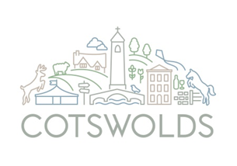
What’s new in the Cotswolds, 2024 and beyond.

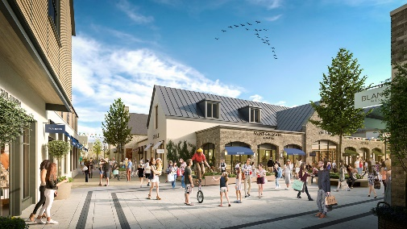
Designer Outlet Cotswolds – A new designer outlet planned for near the M5 in Gloucestershire will bring thousands of shoppers to the area and transform the region.
The six acre new retail and leisure destination is being built just off the A46 near Ashchurch and the M5 Junction 9 for Tewkesbury. The first phase is planned to open in Spring 2024.
https://cotswoldsdesigneroutlet.com/

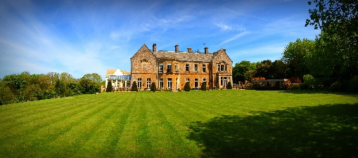
Wyck Hill House Hotel just outside Stow on the Wold was sold to new owners in 2022 who have ambitious refurbishment plans that will build on this well-known and popular hotel. It is hoped the hotel will reopen in winter 2023 once renovations are complete. www.wyckhillhousehotel.co.uk

Imperial Hotel, Stroud
Refurbishment work started in Spring 23 on the old iconic Imperial Hotel located conveniently next to the railway station in the market town of Stroud. Now renamed The Stroud, when completed later this year, the hotel will have 25 bedrooms including 2 family suites and 4 luxury suites with a restaurant and bar for you to get cosy in. The bar will be named The Bucknall Bar after the buildings architect Benjamin Bucknall. The Restaurant and Bar will hold 106 people for dining and there will be event space for 44 dining capacity.
www.thestroudhotel.com

Burford Lodge Hotel
A new local owner plans to refurbish the nine bedroom Burford Lodge Hotel situated on the A40. Plans for the property include the addition of an intimate speakeasy bar complete with baby grand piano and the creation of an upscale Italian bistro, to add to the hotel’s F&B offering.
https://www.boutiquehotelier.com/burford-lodge-hotel-cotswolds-new-owner/

Old Bull Burford
Plans have been submitted to develop the Old Bull and neighboring property into a luxury boutique hotel with 26 standard rooms and 10 suites arranged over several floors. https://www.boutiquehotelier.com/the-old-bull-hotel-burford-refurbishment/
The Bull Inn, Charlbury
Primarily a local pub serving good beer, it also has a restaurant centred around open fire cooking. At The Bull they want to cut out the middle man. We have daily conversations with our farmers and growers which means our menu is constantly changing.
Our rooms are perfect for a single night stay or a long weekend away and have everything you need for a relaxing countryside escape. Rooms feature freestanding baths and king sized beds. Bookings will be open soon.
The Bull is only a short train ride from London Paddington and 8 minute walk from Charlbury station, making it the perfect way to spend a sunny day escaping the city.

https://thebullcharlbury.com/

Great Wolf Lodge, Chesterton
This major £200 million investment is taking shape just outside of Bicester with this being the company’s first European resort. In keeping with the company ethos, Great Wolf Lodge will provide a one-of-a-kind family resort experience offering everything under one roof including entertainment, attractions and dining.
https://greatwolfuk.co.uk/
Tunnel Inn, Coates Cirencester

Plans by Bathurst estate to bring a historic Inn back to life have been given the go ahead and work is now underway. The plans also include six modular holiday pods.
https://www.gazetteseries.co.uk/news/23594432.plans-see-tunnel-house-coates-near-cirencester-re-open/

The Old Rectory Restaurant, Colesbourne
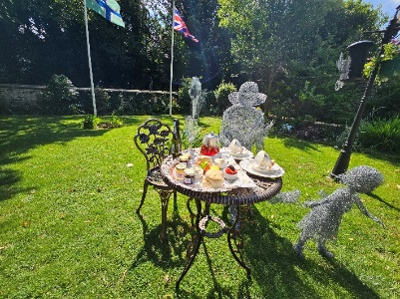
The Old Rectory Restaurant & Sculpture Garden, Colesbourne has re-opened after a refurbishment by its new owners Jason and Michelle Aplin. After 15 years in New Zealand they have settled in the Cotswolds to present Michelle’s sculptures and the skills of Chef of the Year 2019 Dan Richards. Licensed and open 6 days a week. Booking is advised and Groups are welcome.
www.oldrectoryrestaurant.co.uk

GLOUCESTER will be getting a new 131 bedroom hotel as part of the citys ongoing regeneration. https://www.gloucestershirelive.co.uk/news/gloucester-news/gloucester-international-boutique-hotel-chain-8237899

Number Four Stow on the Wold
Planning has been submitted for an extension to Number Four located just outside of Stow on the Wold. If granted there would be 22 new bedrooms and extended dining facilities as well as solar panels. https://www.gloucestershirelive.co.uk/whats-on/whats-on-news/cotswolds-hotel-restaurant-seeks-double-8747450

Anniversaries in 2024

- Anniversary for Holst, the composer who was born in Cheltenham. 150th anniversary of Holst’s birth & also the 90th anniversary of his death.

- We also have the 80th anniversary for the creation of one of the machines which led to the birth of computing. Given the links to Cheltenham and GCHQ we’re looking at some exciting events to promote this through 2024.

- Cheltenham Festival 2024 is celebrating 100 years of the Gold Cup across the week of racing.
https://www.thejockeyclub.co.uk/cheltenham-festival/gold-cup-100/

- Royal International Air Tattoo Fairford will be on July 19, 20, and 21 and will celebrate 50 years of the F-16 Fighting Falcon. The jet has appeared in numerous films including Transformers and The Jewel of the Nile. https://www.airtattoo.com/

- 75th anniversary of the Cheltenham Literature Festival, the world’s longest-running literary festival, in 2024.
- Winston Churchill 150th anniversary of his birth in 2024 so with connections to Blenheim Palace we expect some local events planned around this.

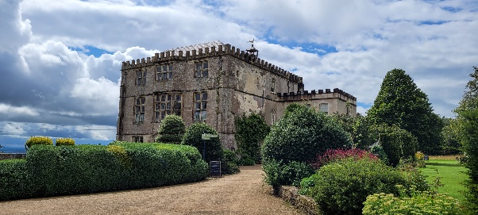
In 2024 Newark Park will be celebrating 75 years in the care of the National Trust. Newark Park was originally built in 1550 as a hunting lodge by Sir Nicholas Poyntz, a key member of Henry VIII’s court. Since then, the estate has been shaped by the people who have lived here throughout its almost 500-year history. However, one thing that has never changed is Newark Park’s appeal: a tranquil spot where pleasure, entertainment and hospitality are prized. To mark the anniversary, visitors will have the opportunity to share their favourite things about the site and the memories they have made here. This will include a memory tree and an exhibition focusing on the conservation works that have taken place over the last 75 years.

New Events
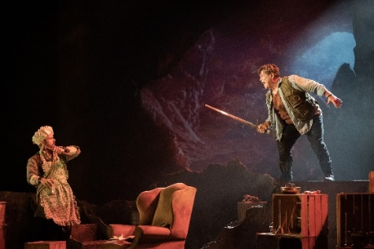
Longborough Festival Opera is an ambitious annual summer festival, taking place in a 500-seat home-grown theatre in the North Cotswolds. 2024 sees a new production of Wagner’s Ring created especially for Longborough by Amy Lane, Artistic Director of Copenhagen Opera Festival, and Longborough’s Music Director and eminent Wagnerian Anthony Negus. Der Ring des Nibelungen (known as the Ring cycle) is a story of gods, giants and heroes, and their struggles for power. Wagner’s cycle is the most epic of tales, a monumental work of art with a score that is searing, desperate and sublime. The full cycle consists of four operas taking place across a week: Das Rheingold, Die Walküre, Siegfried, and Götterdämmerung and is the pinnacle for any opera lover to enjoy. Cycle I: 16 – 22 June 2024, Cycle II: 25 June – 30 June 2024, Cycle III: 4 – 9 July 2024
LFO.org.uk/ring

Looking towards 2025 & beyond

Cotswolds Canal project
Work continues to bring the Cotswold Canals to life with the Cotswold Canals Connected, (Phase 1B of the Cotswold Canals restoration project), marking the next exciting phase of canal restoration for the Cotswolds. It will link the Stroudwater Navigation canal with the Gloucester and Sharpness canal at Saul Junction. It will join our communities, towns and villages with the rest of the UK’s canal network, present new business opportunities and create a vibrant tourist destination in the heart of the Cotswolds.

Luxury Holiday Park, Leafield Oxfordshire
A planning application has been submitted for development at Leafield Technical Centre, to comprise of 51 holiday cabins, eight barn-style cabins and two loft houses to be created out of an existing building by holiday accommodation developer Cabu. It hopes to offer first rate hideaway experiences and create a new indoor swimming pool, a spa, outdoor hot tubs, changing rooms, housekeeping rooms, staff rooms, a reception area, a shop, a new bar and restaurant, covered open socialising space, and studio space. If plans are given the go ahead it is hoped to be operational late 2025.

Recently opened accommodation or about to open in the Cotswolds
The Bell at Charlbury - Daylesford is set to launch a new pub with rooms called The Bell at Charlbury this autumn, the group’s first market town accommodation offering. The 17th century Cotswolds inn will open following a full refurbishment, with the 50-cover pub serving a selection of hearty pub classics with ingredient-led dishes that ‘celebrate and hero the flavours of seasonal produce. 12 bedrooms will sit above the pub and The Barn, including a two-bedroom family suite. Each bedroom draws inspiration from the neighbouring ancient woodland
https://www.thebellatcharlbury.com/

The Fox at Oddington - Part of the Bamford collection, this 19th century coaching inn sits at the heart of the village and has been restored to its former glory using local craftspeople and a sustainable approach. Now with bedroom interiors inspired by the surrounding countryside and with a spacious Coachman’s House opposite for larger groups, a welcoming bar and delicious food this inn looks forward to welcoming you. https://thefoxatoddington.com/

Harcomb Farm Shepherds Huts.
Nestled in the stunning Cotswolds surrounded by rolling hills and honey-coloured cottages, lies the village of Chastleton, home to Harcomb Farm brand new Shepherds Huts. It is the perfect destination for a romantic getaway, relaxing mini break, or a walking holiday. Come and relax in the heart of the Cotswolds, unwind in the wood fired hot tub, enjoy some of the delicious food that the local pubs and restaurants have to offer. The huts sleep two adults, have their own built-in shower and loo, small kitchen with hob, microwave and breakfast bar. Each hut is located within a tranquil, enclosed meadow each with a private patio area, wood-fired hot tub, outdoor furniture, and a fire pit. https://harcombfarmshepherdshuts.co.uk
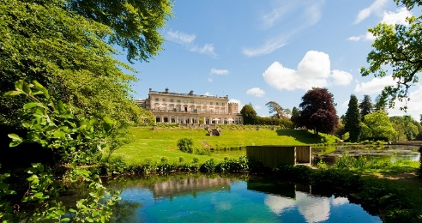

Experimental Group reopened Cowley Manor in summer 2023 following an extensive refurbishment including the introduction of four new rooms.
www.cowleymanor.com

Blenheim Palace – Darwin Escapes
From Summer 2023, visitors have been able to stay on a brand new Lodge retreat set in the stunning Blenheim Palace Estate. Construction has already started on a collection of one, two and three-bedroom lodges partnered with Darwin Escapes
www.blenheim.org/news/luxury-retreat-lodges
Estelle Manor, Eynsham Oxfordshire
The much anticipated Estelle Manor opened its doors in summer 2023 and while there are some areas that are a private members club, the manor is a hotel open to all, with 108 bedrooms, four restaurants and all the trimmings. Further enhancements will be following including Eynsham Baths an extraordinary Roman-inspired spa.
https://estellemanor.com/

For more information on what is new in the area, please email cotswoldstourism@cotswold.gov.uk

